Name: | ____________________SOLUTIONS____________________ |  |  |  |  | Date: ___________
 | Year 10 Mathematics  Investigation 2, 2015  Topic – CAS Equations  In class component |  |  |  |  | 72  = %
Total Time: | 60 minutes
Weighting: | 10% of the year.
Equipment: | Instructional Booklet, CAS Calculator
Instructional Booklet weighting: |  | 0% of the year |  | In-class validation weighting: | 10% of the year.
AIM: To demonstrate your understanding of how to use a CAS calculator to work with equations and to sketch graphs.

IMPORTANT: With all questions, full credit will only be given with working as demonstrated on page 5 of the instructional booklet.

1. | [12 marks; 3,3,3,3]
 | Expand and Simplify the following
 | a. (x+1)(x+2)(x+3)  expand((x+1)(x+2)(x+3))  x³+6x²+11x+6 | b. 4(x²-2x)=3(x+2)  expand(4(x²-2x)-3(x+2))  4x²-11x-6
 | c. 4(2x+3)-5(x+7)+2x(x+3)  expand(4(2x+3)-5(x+7)+2x*(x+3))  2x²+9x-23 | d. (3x+1.2)(17.4-0.2x)(18-5.2x)  expand((3x+1.2)(17.4-0.2x)(18-5.2x))  3.12x³-280.992x²+826.704x+375.84

2. | [12 marks; 3,3,3,3]
 | Factorise the following
 | a. ${5x}^{3}+{13x}^{2}-\frac{159x}{4}+\frac{27}{2}$  factor(5x³+13x²-159x/4+27/2,x)  (2x-3)(2x+9)(5x-2)/4 or  5(x-1.5)(x-0.4)(x+4.5) | b. ${2x}^{3}-{11x}^{2}-x+30$  factor(2x³-11x²-x+30,x)  (x-5)(x-2)(2x+3)
 | c. ${35x}^{3}-{13x}^{2}-19x-3$  factor(35x³-13x²-19x-3,x)  (x-1)(5x+1)(7x+3) | d. 1024  factor(1024)  2¹⁰
3. | [13 marks; 2,3,3,5]
 | Solve the following, give exact solutions
 | a. ${2x}^{2}+3x-12=0$  solve(2x²+3x-12=0,x)  $x=\frac{-(\sqrt{105}+3)}{4}or x=\frac{\sqrt{105}-3}{4}$ | b. ${5x}^{3}-{22x}^{2}-85x-42=0$  solve(5x³-22x²-85x-42=0,x)  x=−2 or x=−3/5 or x=7
 | c. ${5x}^{3}+\frac{{159x}^{2}}{4}+63x=-27$  solve(5x³+159x²/4+63x=−27,x)  x=−6 or x=−6/5 or x=−3/4 | d. ${{2x}^{5}+{5x}^{4}-89x}^{3}-{170x}^{2}+912x+1440=0$  solve(2x⁵+5x⁴-89x³-170x²+912x+1440=0,x)  x=−6 or x=−4 or x=−3/2 or x=4 or x=5

4. | [10 marks; 3,3,4]
 | Solve the following simultaneous equations, express answers in exact form or to 2 decimal places.
a. $2x+3y=15$
$\frac{3x}{2}-\frac{7y}{3}=53$
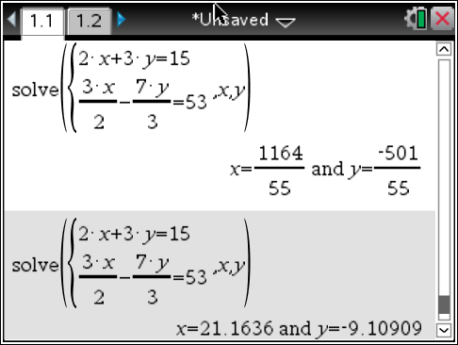working solution for x solution for y -1 if decimal not to 2 d.p.

b. $2.85x+4.23y=103.75$
$5.75x+18.21y=74$
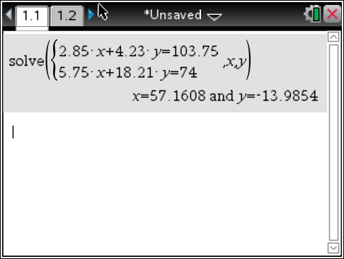 working solution for x solution for y -1 if not to 2 d.p.
c. $4x+5y-3z=22$
$x+y+z=8$
$3x-2y+z=12$
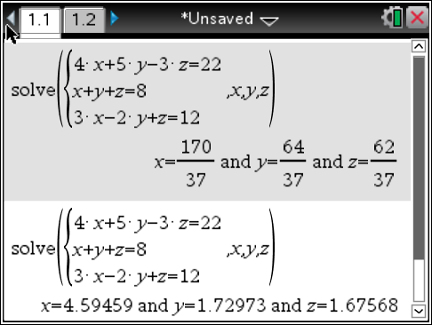 working solution for x y z -1 if decimal not to 2 d.p.

5. | [16 marks; 8,8]
 | Sketch the following graphs, identifying all key points
$\frac{x^{3}}{2}+{3x}^{2}+\frac{3x}{2}-5$
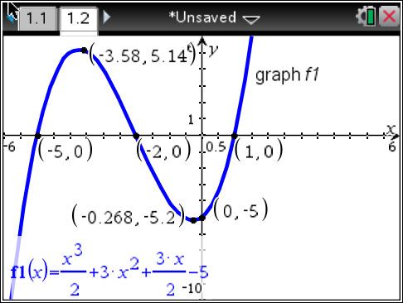

x-intercepts
y-intercept
maximum point
minimum point
drawing of graph -1 if messy and misses points

$x^{3}+{4x}^{2}-4x-16$
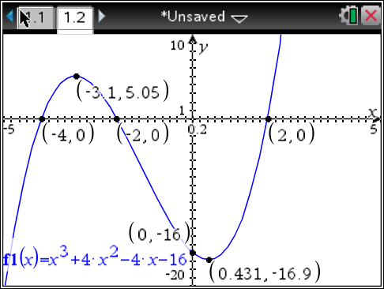

x-intercepts
y-intercept
maximum point
minimum point
drawing of graph -1 if messy and misses points

6. | [9 marks 3,3,3]
Use your CAS calculator to complete the square of the following.
Hint: look carefully at the second screenshot on page 1 of the instructional booklet.
a. $x^{2}+8x+15$

completeSquare(x²+8x+15,x)

(x+4)²-1

b. 2$x^{2}-7x+3$

completeSquare(2x²-7x+3,x)

$2{\left(x-\frac{7}{4}\right)}^{2}-\frac{25}{8}$ or
2.(x-1.75)²-3.125

c. $3x-x^{2}-21$

completeSquare(3x-x²-21,x)

$-{\left(x-\frac{3}{2}\right)}^{2}-\frac{75}{4}$ or
−(x-1.5)²-18.75

~ End of Validation ~

